**Defect 1:**

**Description:** User still see the Profile information even after logging out

**Steps to reproduce:**

1. Login to the application
2. Click on the Profile link
3. Click on the Logout button

**Expected Behaviour:** Navigation should go to homepage from the profile page and the profile information should not be displayed

**Actual Behaviour:** Profile information can still be viewed after logging out

**Screenshot:**

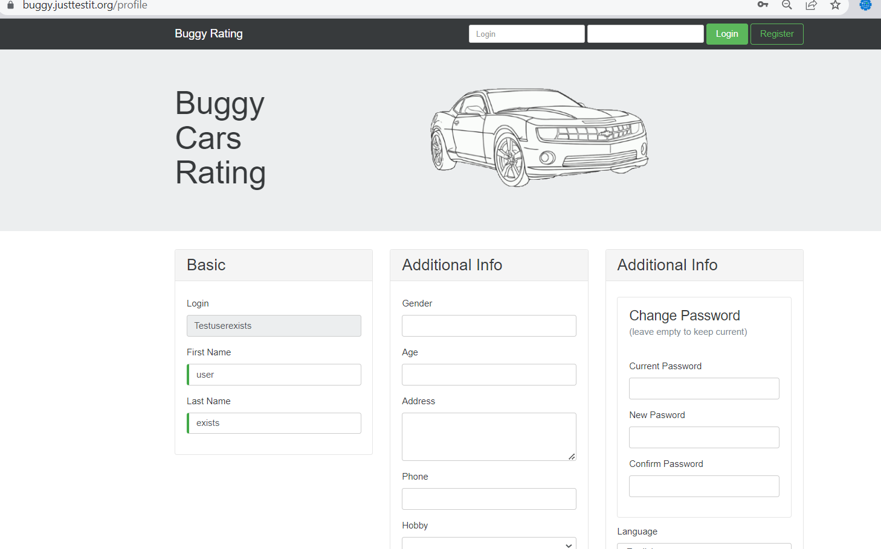

**Priority**: Critical (Sensitivity of the data being compromised)

**Severity**: Critical

**Environment:** Prod

**Defect 2:**

**Description:** Login name during registration process should be unique ignoring the case sensitiveness i.e., even though the user tries to register for the same username but change in the upper case or lower-case letters, the system should NOT allow

**Steps to reproduce:**

1. Launch the application
2. Click on the Register link
3. Provide all the required information with Login field as “Testuserexists”
4. Complete the registration by clicking the “Register” button
5. Do a new registration by following the same steps above with Login field as “testuserexists”

**Expected Behaviour:** System should not allow the second registration as both the usernames are same

**Actual Behaviour:** System allows registration considering Case Sensitiveness

**Screenshot:**

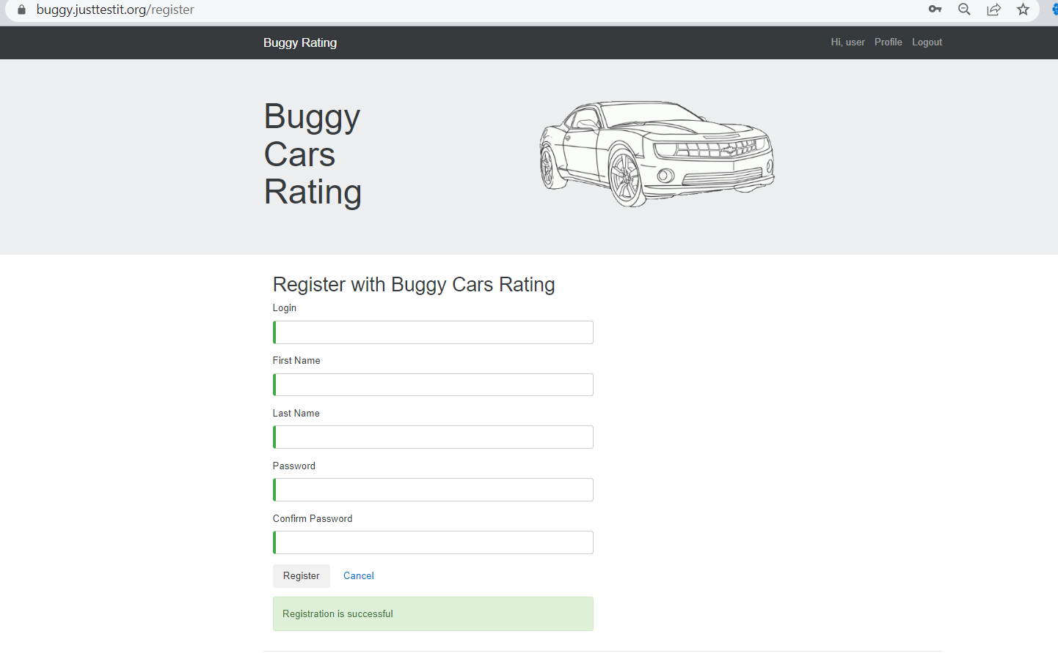

**Priority**: Critical (username should be unique – should not allow duplicate registrations)

**Severity**: Critical

**Environment:** Prod

**Defect 3:**

**Description:** Logout does not work in Overall page

**Steps to reproduce:**

1. Login to the application
2. Click on Overall Rating Module
3. Click on the Logout button

**Expected Behaviour:** User should be logged out from the application

**Actual Behaviour:** User is not logged out – Logout link is broken in overall page

**Screenshot:**

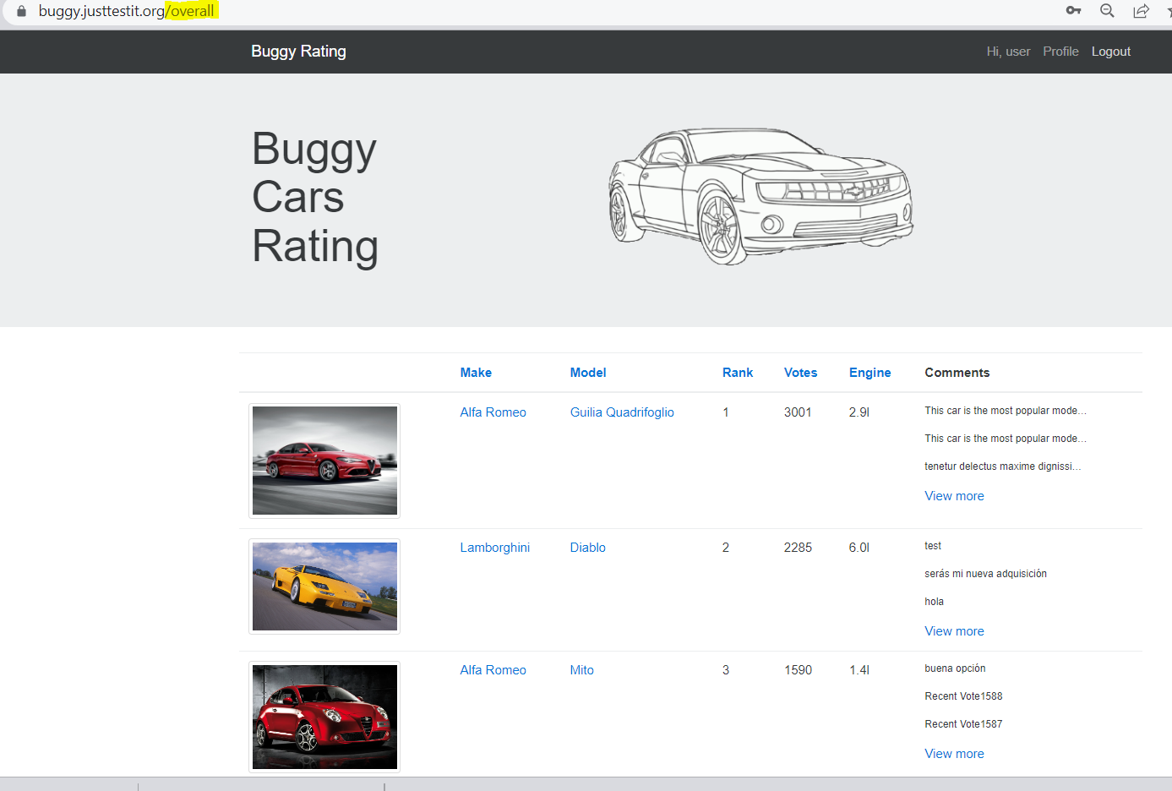

**Priority**: High

**Severity**: High

**Environment:** Prod

**Defect 4:**

**Description:** User is not able to navigate to home page i.e., broken link under Popular Make Page

**Steps to reproduce:**

1. Launch the application
2. Click on the Popular Make tab
3. Click on the Buggy Rating link to go back to homepage

**Expected Behaviour:** System should navigate back to homepage

**Actual Behaviour:** System does not navigate back to homepage and still in make page

**Screenshot:**

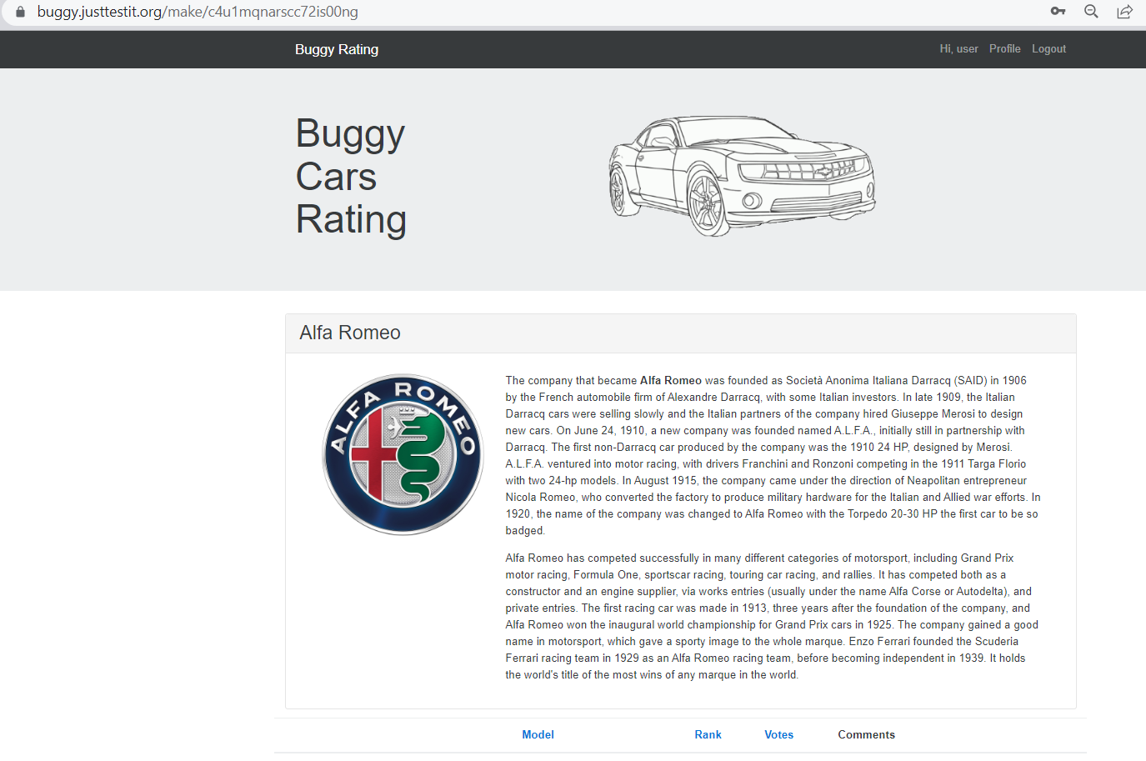

**Priority**: High

**Severity**: Medium

**Environment:** Prod

**Defect 5:**

**Description:** User is still able to register even after logged in: (This can be achieved by accessing the Register URL directly post login)

**Steps to reproduce:**

1. Launch the application
2. Click on the Register link
3. Provide all the required information
4. Complete the registration by clicking the “Register” button
5. Login to the application with the registered username and password
6. Directly access the register URL “https://buggy.justtestit.org/register”

**Expected Behaviour:** System should not allow to do the registration as the current session is still active and the user has been logged in

**Actual Behaviour:** System allows registration even after logging in

**Screenshot:**



**Priority**: High

**Severity**: Medium

**Environment:** Prod

**Defect 6:**

**Description:** Author field is not getting populated after casting a vote for Lamborghini make and Diablo model

**Steps to reproduce:**

1. Login to the application
2. Click on Overall Rating Module
3. Click on Make link Lamborghini
4. Click on Model link Diablo
5. Enter a comment “test”
6. Click the Vote button

**Expected Behaviour:** Date, Author and Comment field should be populated in the table below the model after casting the vote.

**Actual Behaviour:** Date and comment is populated but not the Author field.

**Screenshot:**

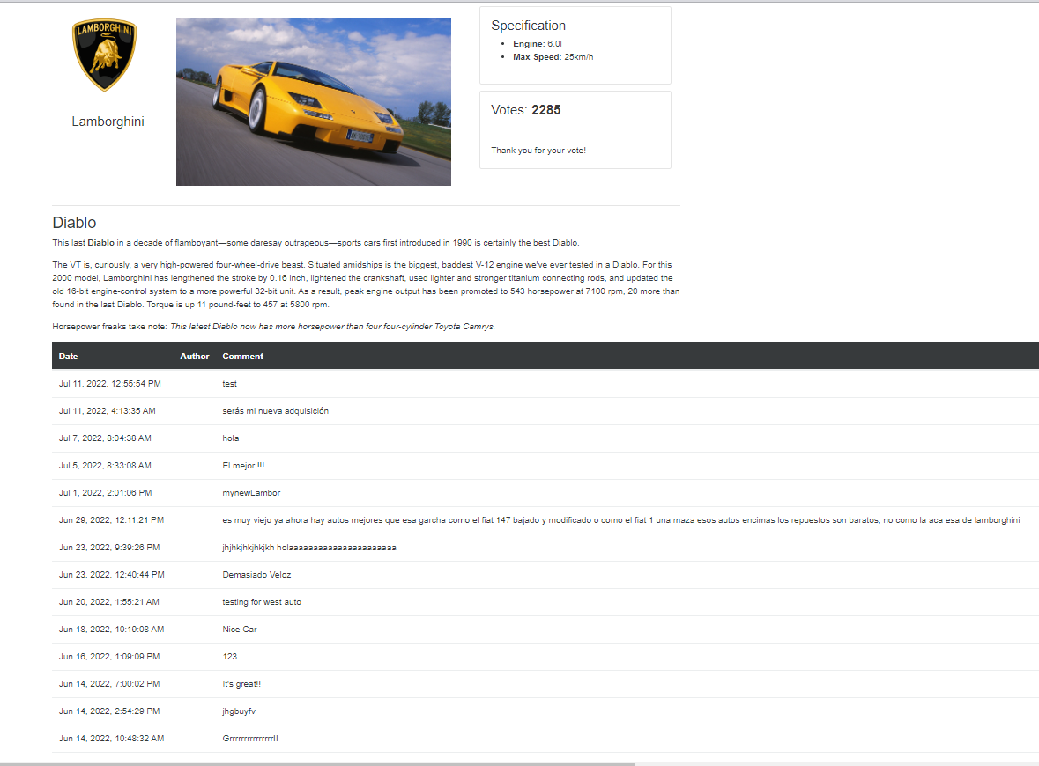

**Priority**: Medium

**Severity**: Medium

**Environment:** Prod

**Defect 7:**

**Description:** Broken Image for the Model ‘Lancia Ypsilon’

**Steps to reproduce:**

1. Launch the application “Buggy Cars Rating”
2. Click on “Overall Rating” section under Homepage
3. Navigate to page containing the Make Lancia and Model Ypsilon

**Expected Behaviour:** Image should be displayed without any issues

**Actual Behaviour:** Broken Image – image is not displayed properly

**Screenshot:**

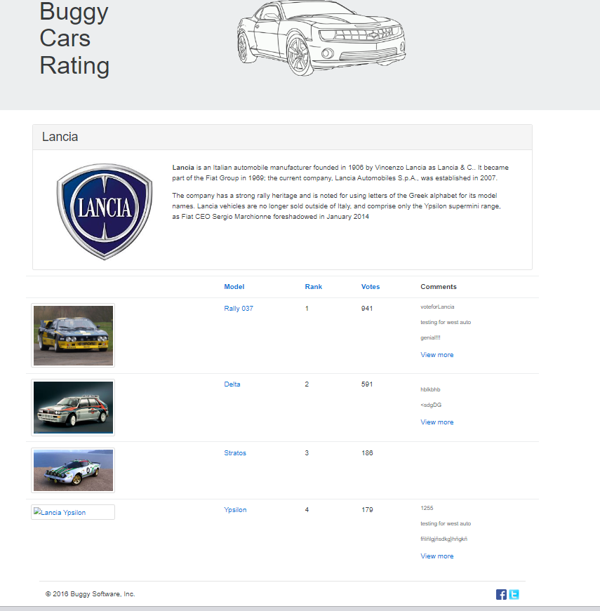

**Priority**: Medium

**Severity**: Medium

**Environment:** Prod